**Action Recognition for Controlling Electronic Appliances in Homes**

**Problem Statement**

Action recognition needs the profound high-level knowledge about human activities to recognize them and control electronic appliances in homes .Generally wearable sensors as well as bespoke sensors are used for tracing the pattern of action recognition among home inhabitants in smart home scenario. Deep learning based methods have been widely adopted for the sensor-based action recognition tasks to control electronic appliances in homes. Human Action recognition (HAR) is a typical pattern recognition (PR) problem. In daily HAR tasks, main challenge is that methods rely on heuristic handcrafted feature extraction, which is usually limited by human domain knowledge. Also only shallow features can be learned according to human expertise, conventional PR approaches often require a large amount of well-labeled data to train the model. In this research a Hybrid deep learning approach is proposed, to develop a device which will recognize action to control devices in smart home. To overcome the above limitation deep learning network structure is more feasible to perform unsupervised and incremental learning. This hybrid model consists of RNN and CNN network for action recognition either in the form of images or in form of signal. Combining CNN and RNN will enhance the ability to recognize different action that have varied time span and signal distributions. The objective of this research is to develop such a system which will help physically challenged people to control home Electronic devices by gestures using MEMS accelerometer also. The device will help the aged persons too.

**Background**

Basically, Gestures include motion of the hands and face. A gesture can be divided into different categories: dynamic gesture and static gesture. Gesture recognition is movement of human action by computing device. Gestures can obtain from any bodily motion but commonly obtain from the face or hand. Conventional PR approaches have made progress on HAR by adopting machine learning algorithms such as decision tree, support vector machine, naive Bayes, and hidden Markov models. Approaches like GSM based system for controlling the Appliances for the people who are not at home, are proposed this is done remotely through SMS over GSM network using AT commands and on receiver the GSM modem is interfaced with the PC, the home appliances control system is developed on the PC to monitor and control. Also system using Arduino and a GSM module, which forms the server side of the system are also proposed. The development of smart environment is focused in supporting and assisting people in activities of daily living (ADL). New approaches and algorithms from the sensor based events have also appeared. It takes the sensor fusion readings as inputs and predicts a user’s ADL. Smart environment such as building, room and house are well equipped with various sensors including light sensors, motion sensors .Example of such smart appliances are Nest Thermostat, Honeywell Lyric Thermostat, and Canary etc.

**Methodology**

**Step 1: Data collection and dataset preparation**

This will involve collection public dataset and self-collection of dataset and then feature extraction is to be done by applying preprocessing.

**Step 2: Developing a Hybrid Model Action Recognition for Controlling Electronic Appliances with MEMS Accelerometers**

In this step a Hybrid model that contains CNN and RNN along with MEMS accelerometers is developed for Action Recognition for Controlling Electronic Appliances in homes, Pooling, weight sharing, input adaptation is applied here. MEMS accelerometers are micro-electromechanical systems used to measure the force of acceleration. In the proposed system accelerometer sensors are used for interaction with home electronic devices using recognized gestures that are human actions to control devices in smart home.

**Step 3: Training and experimentation on datasets**

The Hybrid model will be than trained on the dataset and testing is also performed like the appliances are able to recognize the actions or not and if they are recognizing than are they able to proper action as a counter step.

**Step 4: Deployment and analysis on real life scenario**

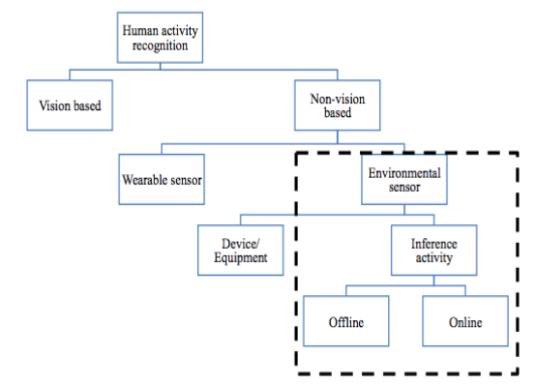

Figure.1 Taxonomy of Human Action Recognition System in Smart Home [Mohamed, Raihani, et al. "Multi Label Classification on Multi Resident in Smart Home using Classifier Chains." Adv. Sci. Lett., vol 4.400-407 (2016): 8-12.]

The trained and tested hybrid model will be deployed in a real-life scenario for action recognition by appliances in home& will be leveraged for further improvement in the methodology and will follow the above taxonomy and below mentioned flow chart.

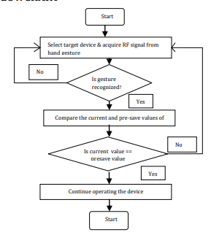

Figure.2 Flowchart for Human Action Recognition System controlled devices in Smart Home [Jadhav, Jyoti, and Prashant Avhad. "Hand Gesture Based Home Appliances Control System." (2017)]

**Experimental Design**

**Dataset**

WSU Casas Public Datasets (<http://casas.wsu.edu/datasets/>) , Self data collection will be used for experimentation and evaluation**.**

**Evaluation Measures**

Measures such as Accuracy, Time taken to recognize the action by appliances will used as a parameter to do evaluation.

**Software and Hardware Requirements**

Python based Computer Vision and Deep Learning libraries will be exploited for the development and experimentation of the project. Tools such as Anaconda Python and libraries such as Tensorflow, OpenCV and Keras will be utilized for this process. Training will be conducted on NVIDIA GPUs for training the hybrid model for Human Action Recognition System in Smart Home by appliances.